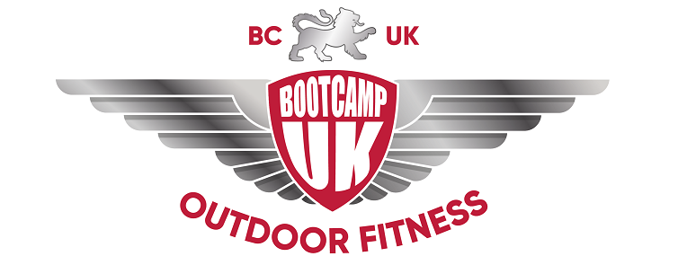

Congratulations on becoming a Bootcamp UK member!

Please find enclosed your QR Code Keyring which you will need to bring to each session to sign in.

Please let me know if you have any questions, on steph@bcuk.uk.

Enjoy your new membership with us!

Thank you,

The BCUK Team

