Double Trouble Up
Saved 5

How It Works
Setup 4 lines roughly 10 metres apart.
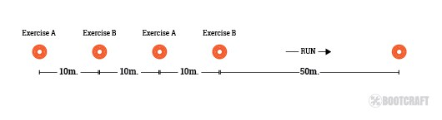
All members start at line 1, and do 4 reps of exercise A.
They then move on to line 2 and do 4 reps of exercise B.
They then move on to line 3 and repeat 4 reps of exercise A.
They then move on to line 4 and repeat 4 reps of exercise B.
After that, they run 50 metres to a cone and back. This is the end of Round 1.
Round 2, 3 and 4 are identical to Round 1, but the reps increase by 4 each time (Round 2 has 8 reps, 3 has 12 reps, and 4 has 16 reps). By round 3 and 4 the ‘easy’ exercises prove challenging!
After each pair of exercises is completed, give your group a rest for a minute or so, then move on to the next pair of exercises. Each completed round takes about 10 mins including rest, so you will typically get through 4 rounds in a one-hour session, adding on 10 mins each for a warmup and cooldown/stretch at the end.

Exercises:
Set 1
- Bicep Curls
- Squat Jumps
Set 2
- Shoulder Press
- Sit Up Claps
Set 3
- Push Ups
- Lunge jumps
Set 4
- Bicycle Kicks (each leg)
- Bent Over Rows
Feel free to substitute any exercises in here you wish. I made sure to have 2 exercises with a different focus (upper body/lower body/core) so as one body part doesn’t get hammered with back to back exercises.
Modifications:
Feel free to alter the number of reps for advanced or beginner individuals.
For advanced I gave them 5 reps, and increase by 5 each round (5, 10, 15, 20)
For beginners I gave 3 reps and increase by 3 each round (3, 6, 9, 12)
At the start though, I just told everyone the 4 reps, then as they started I told the group anyone wanting to do the advanced version can do the 5. I then went over and quietly told the beginners they can do the 3 reps. I try not to make this an obvious thing, as some can get a bit embarrassed if you announce to the whole group that they are doing less reps.

